**JOMO KENYATTA UNIVERSITY OF AGRICULTURE AND TECHNOLOGY**

**BSc. COMPUTER SCIENCE**

**ICS 2209: DESIGN AND IMPLEMENTATION OF COMPUTER APPLICATION**

**LOCATE AND GO**

**GROUP MEMBERS:**

1. JOAN KINOTI SCT211-0042/2022
2. MELANIE MINAYO SCT211-0043/2022
3. MOSES ODENY SCT211-0099/2022
4. FAITH MOSONIK SCT211-0044/2022

Table of Contents

#### Introduction

#### Potential Client Users

1. **What the software will do**
2. **Implementation Plan**

#### Problem Statement

#### Technology

1. **Requirement Specifications**
   * 7.1 Functional Requirements
   * 7.2 Non-Functional Requirements

#### Feasibility Study

* + 8.1 Schedule Feasibility
  + 8.2 Technical Feasibility

#### System Design

* + 9.1 Database Design
  + 9.2 Flow Chart
  + 9.3 User Interface Design
  + 9.4 Architectural Design

#### Testing

#### Maintenance

1. **Conclusion**



# Introduction

Locate and Go is a groundbreaking transportation application designed to cater to the needs of individuals and businesses seeking efficient and reliable relocation services across different parts of the country. With an extensive network of transport companies, our application aims to simplify the process of selecting the ideal transportation service provider for the specific goods and belongings that require relocation.

# Potential client Users:

1. Individuals Relocating Homes: People who are moving to a new city or state and need to transport their household goods and personal belongings.
2. Corporate Relocations: Companies that are relocating their offices or employees to different parts of the country and require efficient transportation services for their office equipment, furniture, and other assets.
3. Small and Medium-Sized Businesses: Businesses that need to transport their inventory, products, or supplies to different locations within the country.
4. E-commerce Retailers: Online retailers who require reliable transportation services to deliver products to customers across the country.
5. Event Organizers: Organizations hosting events or trade shows in different cities or states that need to transport event equipment, materials, and supplies.
6. Furniture and Appliance Retailers: Retailers specializing in furniture, appliances, or other large items that need transportation services to deliver products to customers in various locations.

# What the software will do:

Extensive Network of Road Transport Companies:

Locate and Go features an extensive network of road transport companies that specialize in domestic relocations. These companies are carefully vetted and selected based on their expertise, reliability, and adherence to safety standards.

Intuitive User Interface:

The application offers an intuitive and user-friendly interface, ensuring that clients can navigate and utilize the software effortlessly. The interface will provide a seamless experience, making it easy for users to find and select the ideal road transport company for their relocation.

Advanced Search and Filtering:

Locate and Go provides advanced search and filtering options to help users refine their choices. Clients can specify their requirements, such as the origin and destination locations, preferred pickup and delivery dates, and any specific needs or preferences. The application then generates a list of road transport companies that align with these criteria.

Detailed Company Profiles:

Each road transport company listed on Locate and Go has a dedicated profile that contains essential information. This includes details about their fleet, capabilities, service offerings, and customer reviews. These profiles empower clients to make informed decisions by providing insights into the expertise and reputation of the transport companies.

Transparent Pricing and Quotes:

Locate and Go ensures transparency in pricing by providing clients with accurate quotes from the road transport companies. Users can compare the pricing, services, and any additional charges associated with each option. This transparency allows clients to select the road transport company that best fits their budget and requirements.

Easy Booking Process:

Once clients have chosen their preferred road transport company, Locate and Go offers a seamless booking process within the application. Users can securely book their road transportation services, specify pickup and delivery details, and make necessary arrangements directly through the platform.

Customer Support and Feedback:

Locate and Go provides dedicated customer support channels to address any inquiries or concerns that users may have. Additionally, the application encourages clients to provide feedback and rate their experience with the road transport companies. This feedback system promotes transparency and helps maintain service quality within the platform.

# Implementation Plan

**Requirement Gathering and Analysis**: Conduct thorough research to understand the needs and pain points of house call workers, and define the project scope and requirements.

**Design and Prototyping**: Create wireframes and prototypes to visualize the user interface and user experience, and gather feedback from stakeholders for iterative improvements.

**Development**: Implement the core features and functionality of the platform, following best practices and adhering to coding standards and security protocols.

**Testing and Quality Assurance**: Conduct comprehensive testing to identify and address any bugs, errors, or inconsistencies in the system, ensuring a seamless user experience.

**Deployment and Launch**: Deploy the platform to a secure hosting environment, configure necessary settings, and officially launch it to the target audience.

**Training and Support**: Provide training resources and documentation to onboard users and address any questions or concerns, and offer ongoing technical support to ensure smooth operations

**Continuous Improvement**: Gather user feedback, monitor system performance, and incorporate enhancements and updates to meet evolving user needs and industry trends.

# Problem Statement

The process of finding reliable and suitable road transportation services for nationwide relocation is cumbersome and time-consuming. Clients struggle with a lack of comprehensive information about available transport companies, their services, pricing, and customer reviews. Limited options and specialized handling requirements further complicate the selection process. Unclear pricing structures and hidden costs make it challenging to plan and budget accurately. The absence of real-time tracking and communication leads to uncertainty and potential disruptions. Additionally, the lack of robust security measures and verification mechanisms raises concerns about the safety of belongings during transportation. These challenges highlight the need for a solution that simplifies the search, comparison, and booking of road transportation services, ensuring transparency, efficiency, and peace of mind for client

# TECHNOLOGY

* **.NET Framework**

The desktop application will be built primarily using this framework.

* **Docker**

During development, a MYSQL image will run in a docker container to avoid locally installing the database.

* **Visual Studio**

An integrated development environment (IDE) that will be used for developing, debugging, and testing SaleSync.

* **Lucidchart**

A web-based diagramming tool facilitating collaborative creation of the entity relational diagrams (ERDs).

* **Jira**

A widely used project management and issue tracking tool that will be heavily used in project planning and implementation of the Agile Methodology.

# Requirement Specifications

## Functional Requirements

* + - User Registration and Authentication:

Users should be able to create an account and log in securely.

Authentication mechanisms should be in place to ensure the privacy and security of user data.

* + - Transport Company Database:

The application should maintain an extensive database of road transport companies.

Each transport company should have a profile containing relevant information such as services offered, fleet details, insurance coverage, and customer feedback.

* + - Search and Filtering:

Users should be able to search for transport companies based on criteria such as location, services, pricing, and customer ratings.

The application should provide advanced filtering options to narrow down search results based on specific requirements.

* + - Detailed Company Profiles:

Each transport company profile should display comprehensive information about the company, including their capabilities, experience, certifications, and customer reviews.

Users should have access to key details that help them evaluate and compare transport companies effectively.

* + - Transparent Pricing and Quotes:

The application should facilitate transparent pricing by providing accurate quotes from transport companies based on user requirements.

Users should be able to view and compare pricing, additional charges, and any terms and conditions associated with the quotes.

* + - Booking and Scheduling:

Users should be able to book transportation services directly through the application.

The application should allow users to specify pickup and delivery details, preferred dates, and any special instructions.

* + - Customer Support and Feedback:

The application should have a customer support system to address user inquiries, concerns, and issues promptly.

Users should be able to provide feedback and ratings for the transport companies and their services.

* + - Scalability and Performance:

The application should be designed to handle a large number of users and transport companies simultaneously.

Performance optimizations should be implemented to ensure smooth and efficient user experience.

## Non-Functional Requirements

* + - Usability:

The application should have an intuitive and user-friendly interface, making it easy for users to navigate, search for transport companies, and book services.

Clear and concise instructions should be provided to guide users through the process.

* + - Performance and Scalability:

The application should be able to handle a large number of concurrent users and transport company profiles without significant performance degradation.

Response times for search, booking, and tracking functionalities should be fast and efficient.

* + - Reliability and Availability:

The application should be highly reliable, ensuring minimal downtime and disruptions in service.

Adequate server infrastructure and backup systems should be in place to maintain availability.

* + - Security:

The application should implement robust security measures to protect user data, including encryption of sensitive information and secure storage practices.

Authentication and authorization mechanisms should be implemented to prevent unauthorized access.

* + - Compatibility:

The application should be compatible with a wide range of devices and operating systems to ensure accessibility for users.

Browser compatibility and responsiveness on different screen sizes should be taken into

consideration.

* + - Data Privacy and Compliance:

The application should comply with relevant data protection and privacy regulations, ensuring that user data is handled securely and transparently.

User consent for data collection and processing should be obtained and clearly communicated.

* + - Integration:

The application should support integration with secure payment gateways to facilitate seamless and secure transactions.

It should also allow for integration with external systems or APIs for real-time tracking and notifications.

* + - Performance Monitoring and Analytics:

The application should include mechanisms to monitor performance, track user interactions, and gather analytics data to identify areas for improvement.

# Feasibility Study

## Schedule Feasibility:

The project timeline will be carefully planned to ensure timely completion within the allocated

resources and budget.

| **ACTIVITY** | **DURATION** |
| --- | --- |
| Database modeling | 12th - 19th February 2024 |
| UI/UX Design | 19th - 26th February 2024 |
| UI implementation | 26th - 11th March 2024 |
| Coding to integrate functionalities | 11th - 25th March |
| Testing | 25th - 1st April |

## Technical Feasibility

Technically, the system development requires developers proficient in the programming languages used to implement the system.

The system can also be operated by a person with basic computer literacy

# System Design

## Database Design

The database will be designed to efficiently store and manage user profiles, appointment data, messaging history, and financial transactions.

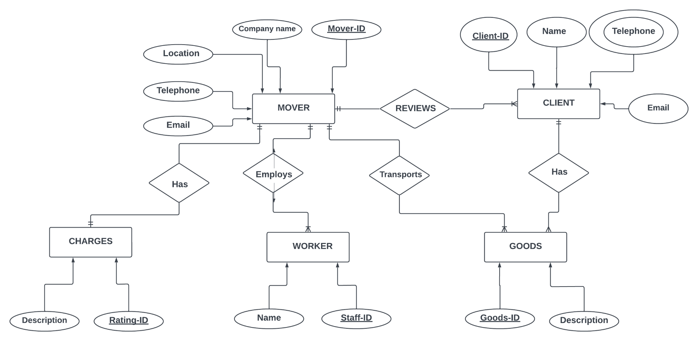

## Flow Chart

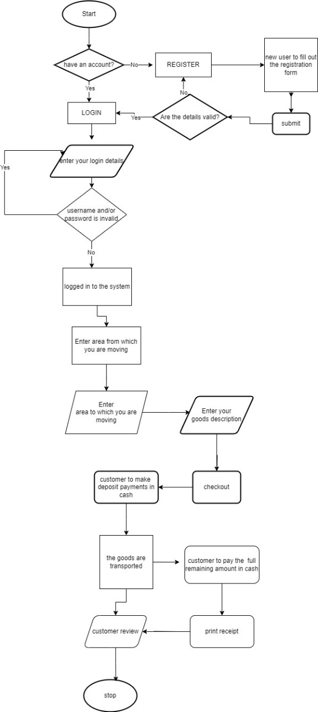

## User Interface Design

The user interface will be designed with a focus on simplicity, usability, and accessibility, catering to the needs of both workers and clients.

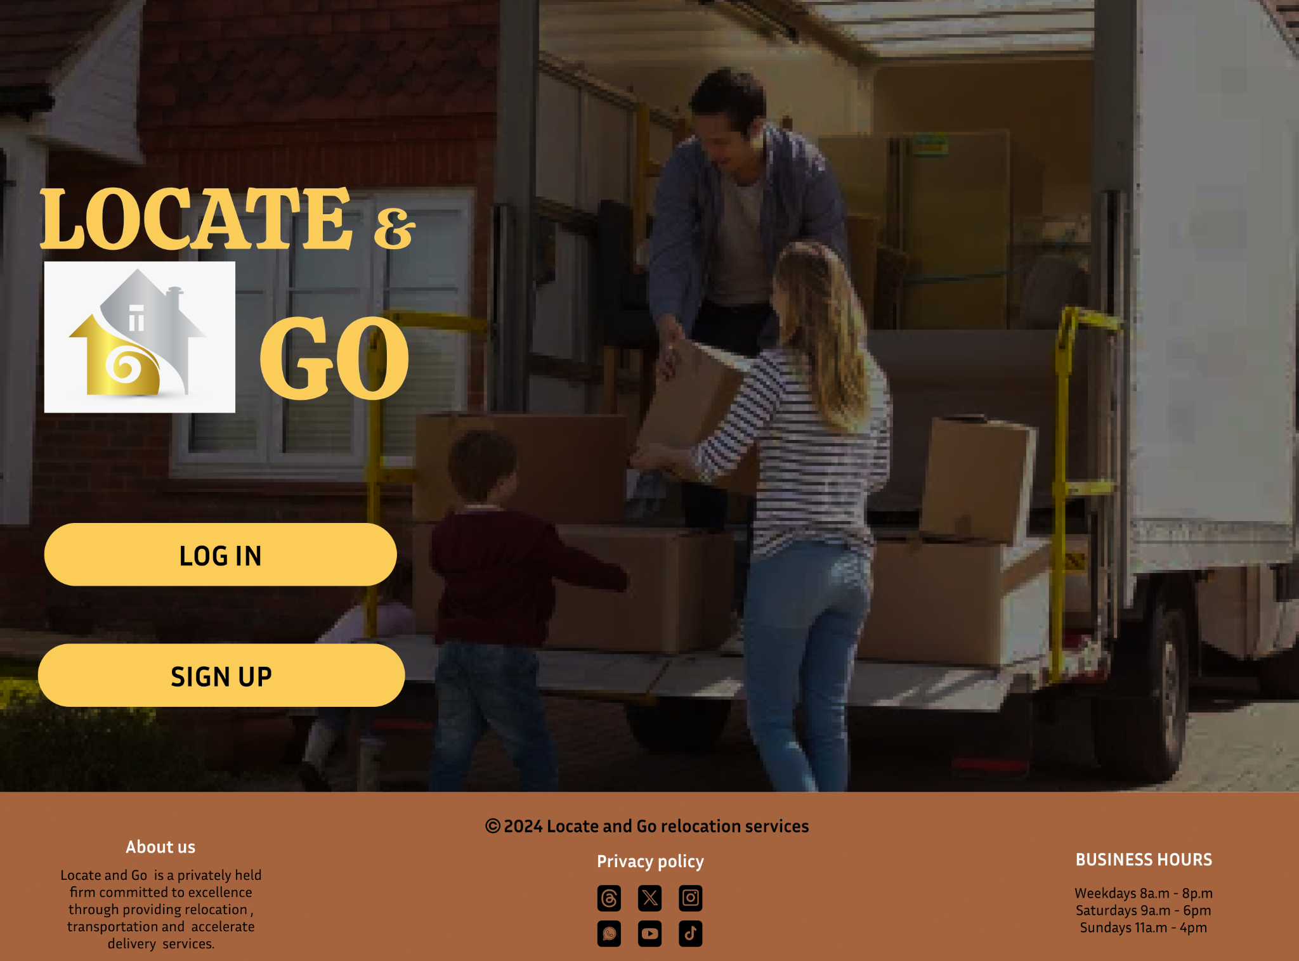

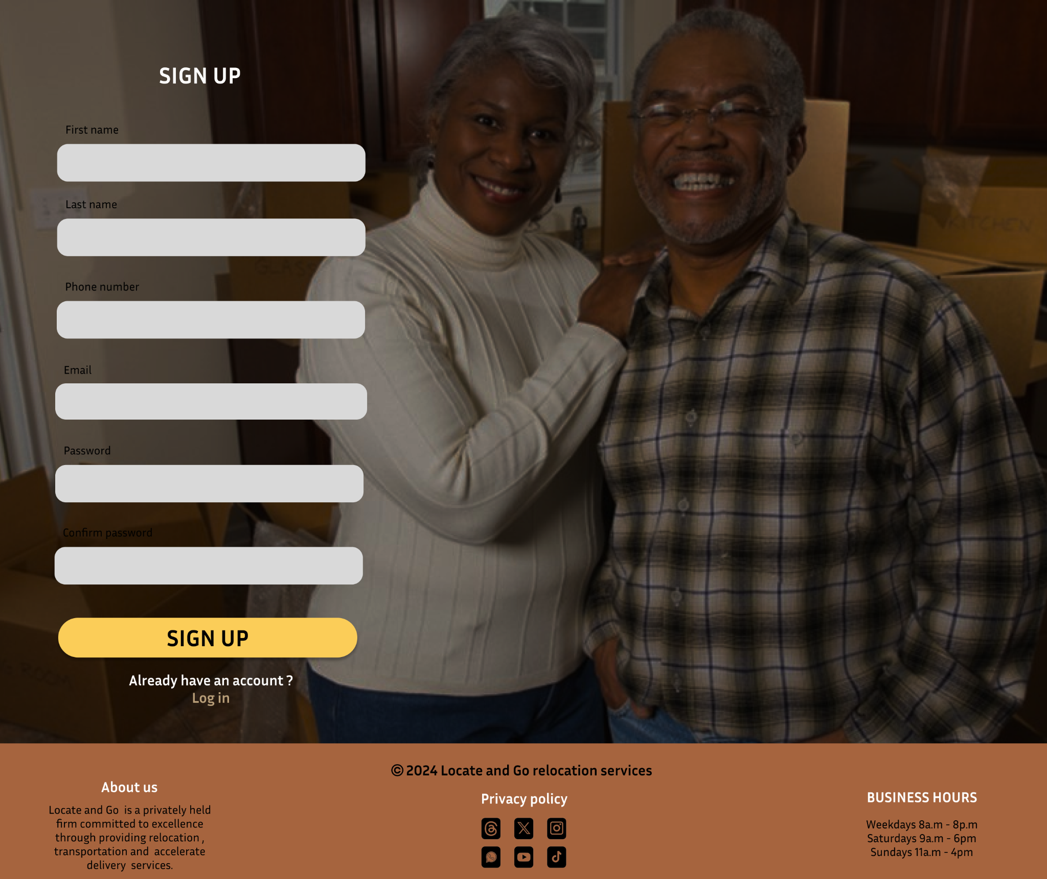

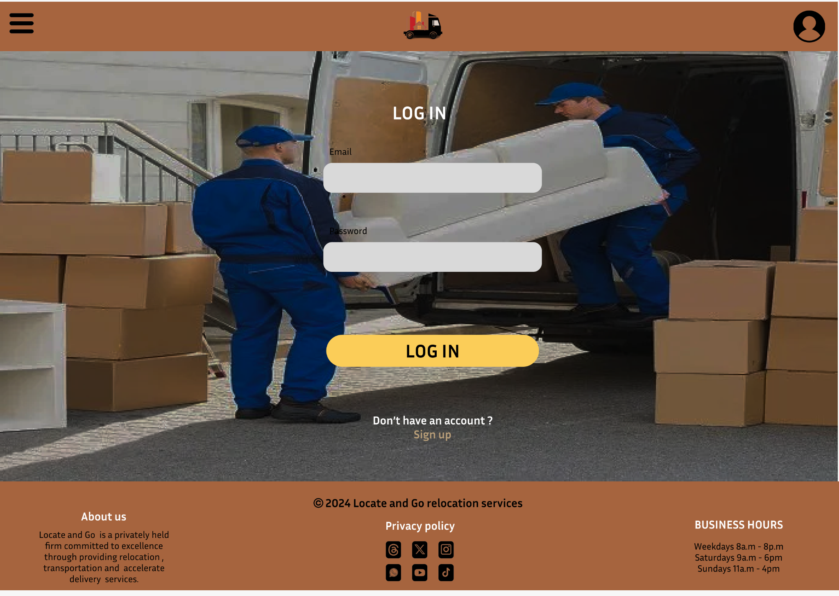

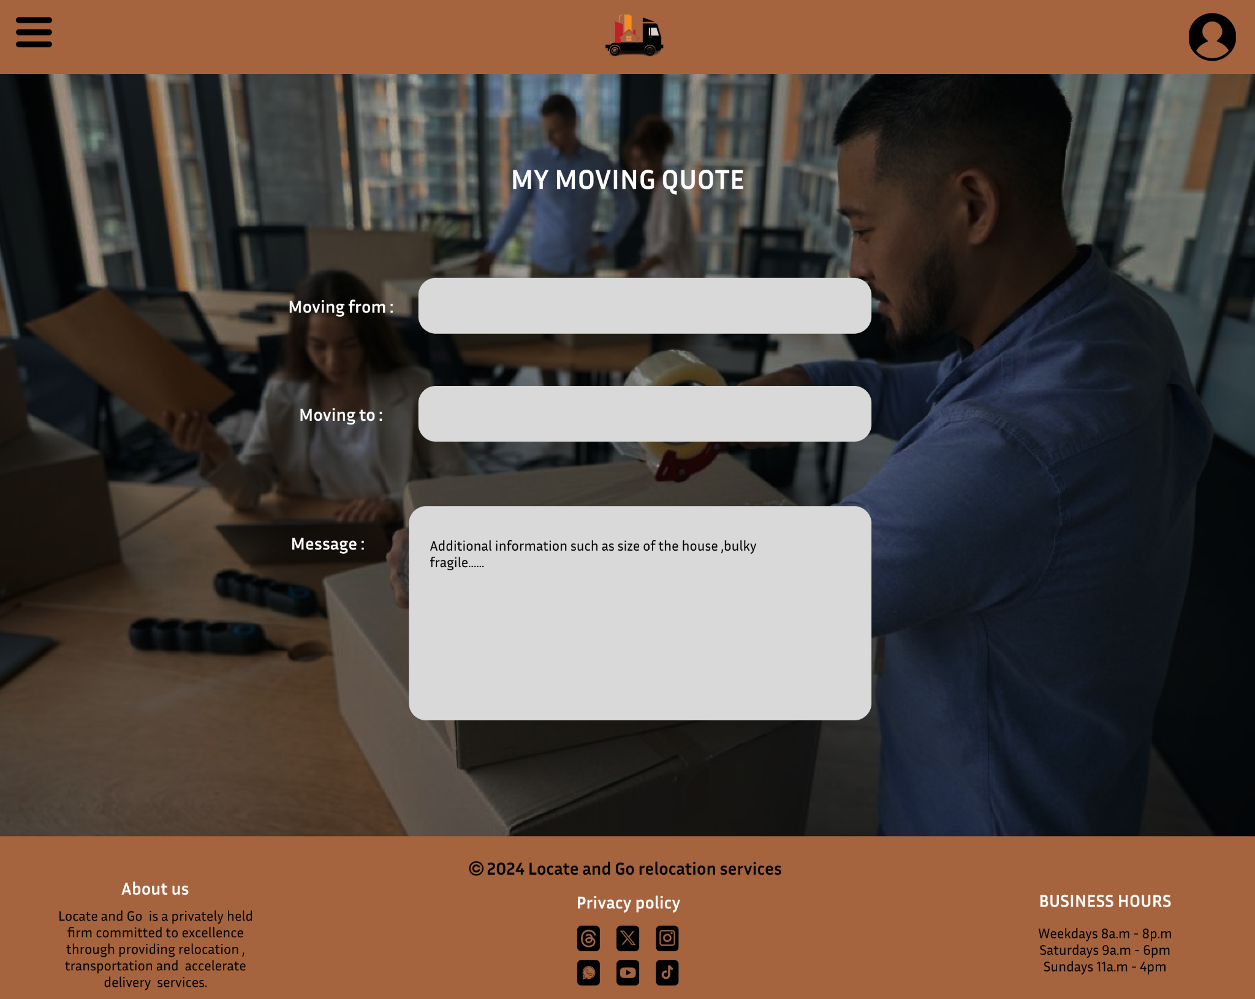

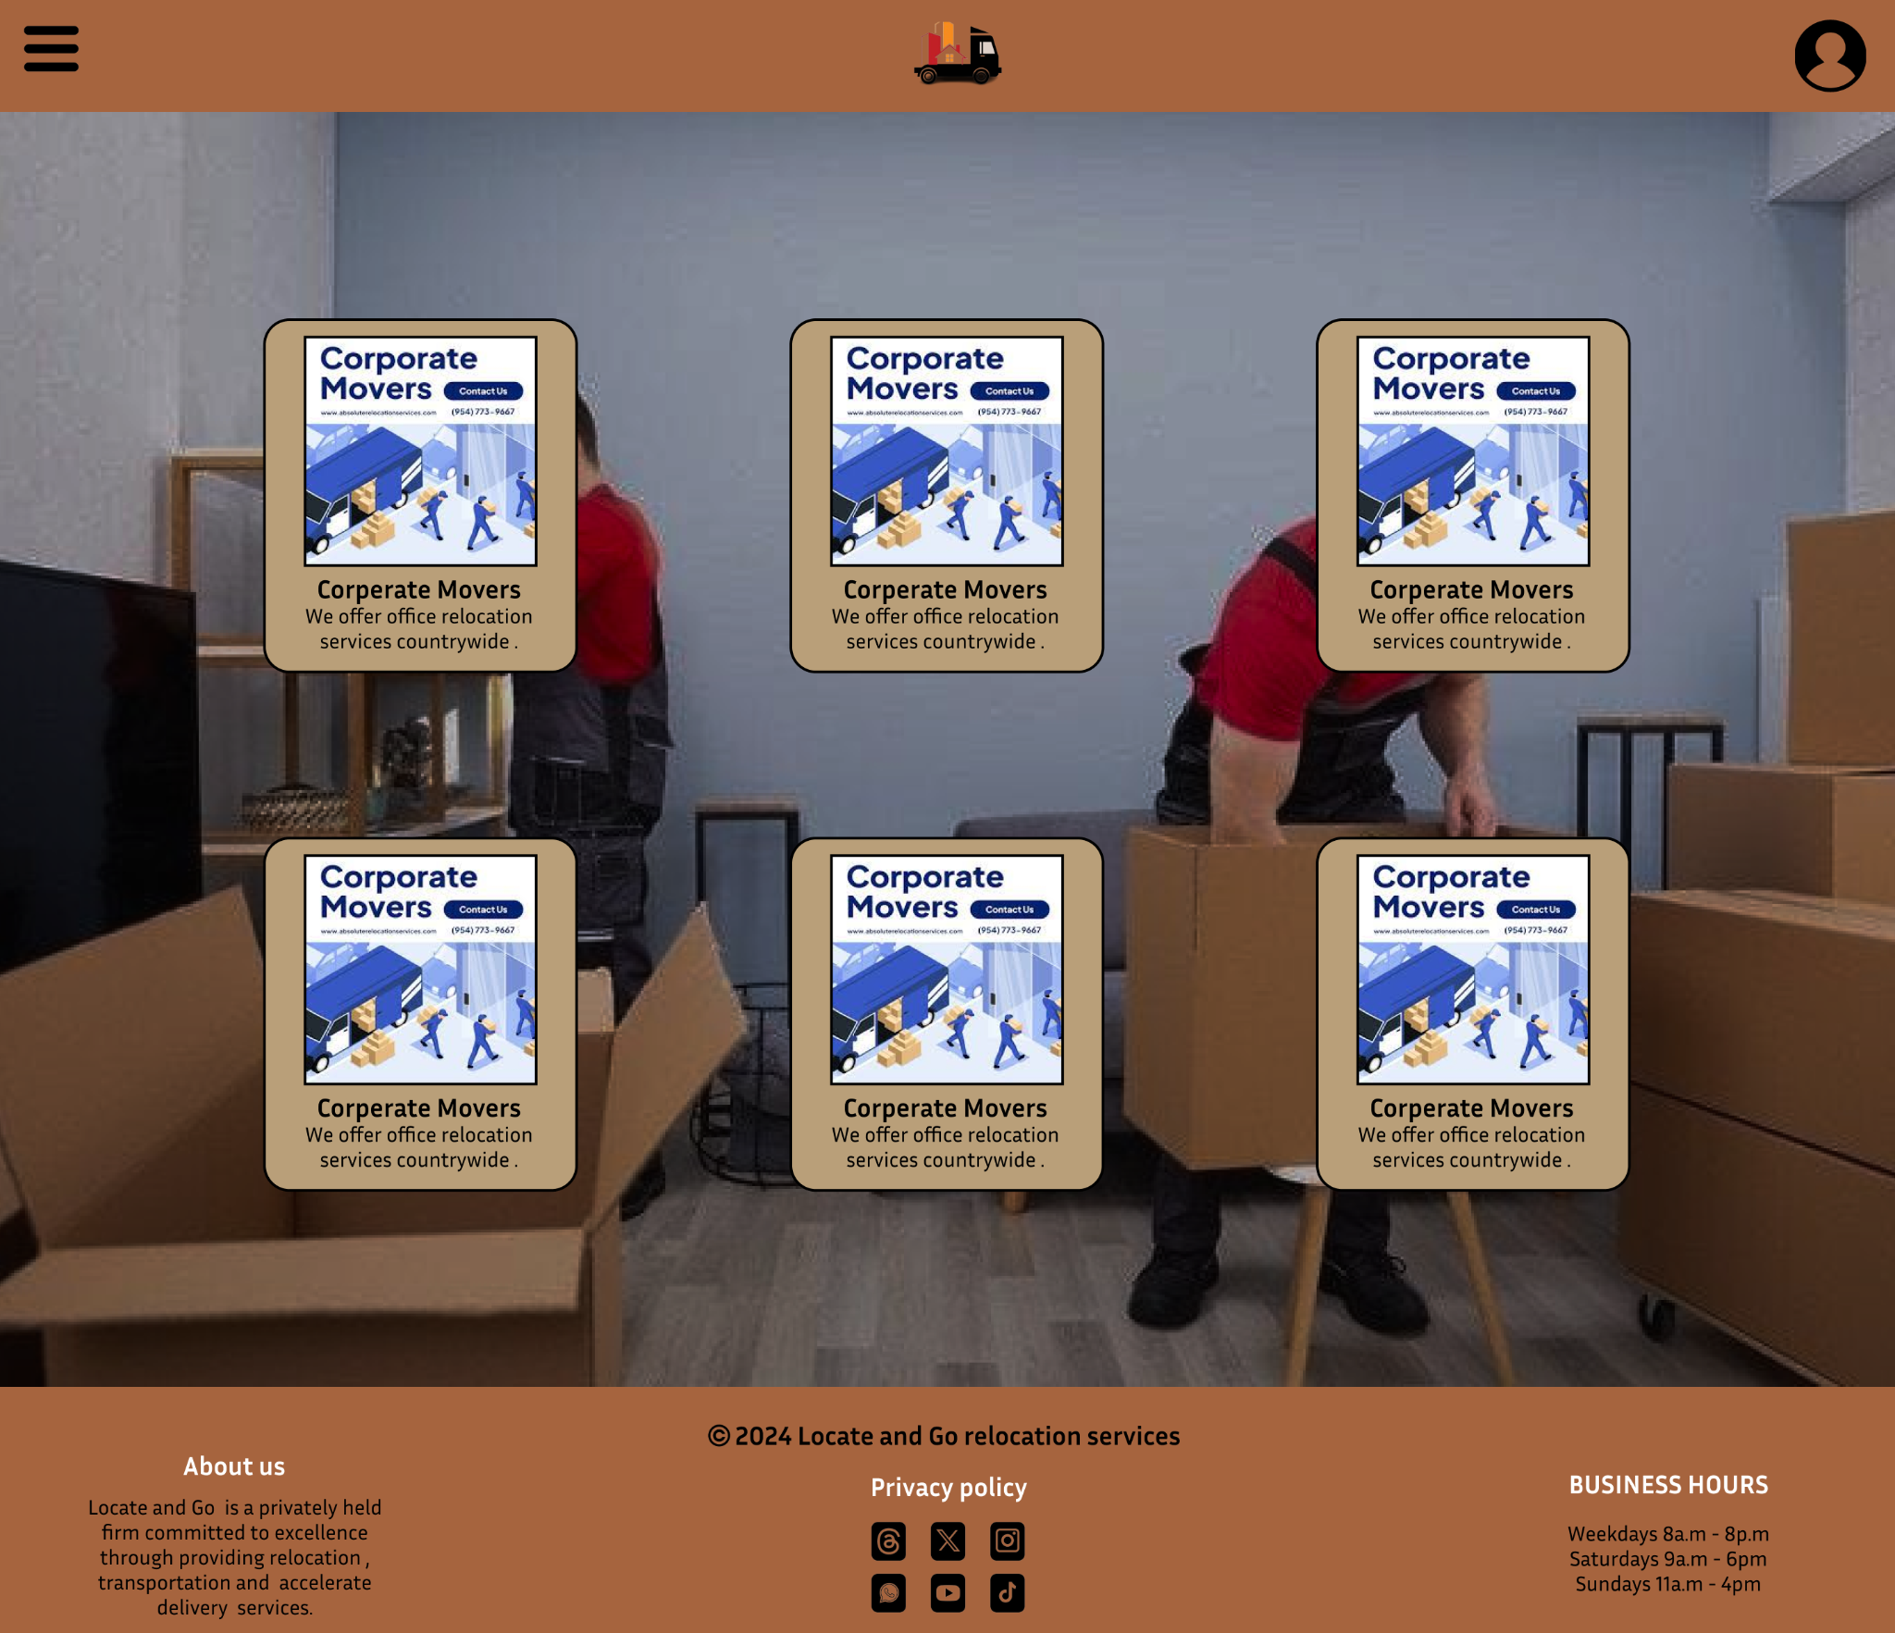

## Architectural Design

Our proposed computer application aims to link moving companies with individuals seeking relocation services. The architecture of the application is designed to ensure scalability, reliability, and ease of use for both moving companies and users.

System Architecture:

The system architecture comprises the following key components:

#### 1. User Interface (UI):

- The front-end of the application will be developed using a user-friendly web-based interface.

- The UI will allow users to create accounts, request moving services, and browse available moving companies.

#### 2.User Authentication and Authorization:

- A robust authentication system will be implemented to secure user accounts and ensure data privacy.

- Authorization mechanisms will differentiate between regular users and moving companies, granting appropriate access levels.

#### 3. Database Management:

- A relational database will store user profiles, preferences, and moving company details.

- The database will facilitate efficient data retrieval, storage, and management of the matchmaking process.

#### 4. Matching Algorithm:

- An intelligent matching algorithm will analyze user preferences and moving company capabilities to suggest suitable matches.

- The algorithm will consider factors such as location, services offered, user reviews, and pricing.

The architecture is designed to accommodate future enhancements, it aims to create a seamless and secure experience for users and moving companies, ensuring a reliable platform for facilitating moving services.

# Testing

Comprehensive testing protocols will be implemented to validate the functionality, performance, and security of the platform.

# Maintenance

Ongoing maintenance and support services will be offered to address any issues, implement updates, and ensure the long-term stability and usability of the platform.

# Conclusion

Our computer application dabbed Locate and Go has been keenly crafted to cater for the needs of people who are in the process of moving be it houses or offices. We are congnisant of the fact that moving can be a really stressful process and there is so much liability involved so we aim at connecting people to moving companies that not only offer topnotch services but also a very seamless experience at the touch of a button.

Thank you for considering our proposal. We are committed to delivering a high-quality solution that makes a positive impact on the lives of people who are desiring to have a seamless moving experience.